**BOOK AND READ**

**ER-DIAGRAM**

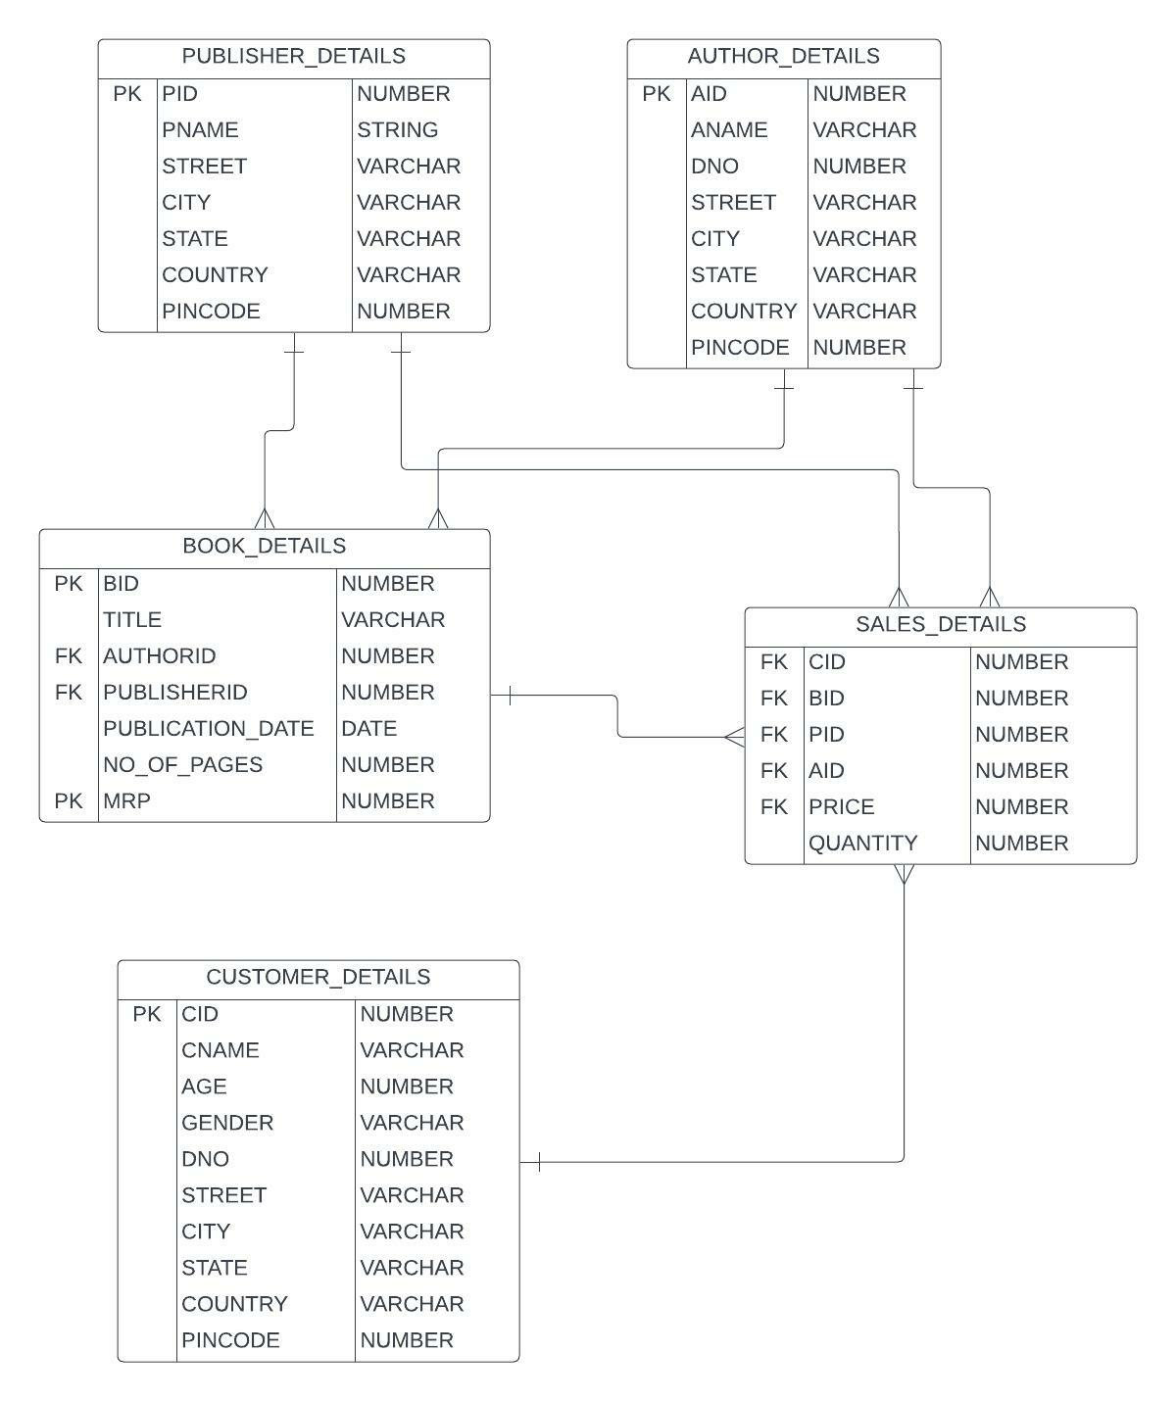

**TABLES**

PUBLISHER_DETAILS

Create Table Publisher_details(Pid number Primary Key,Pname Varchar(30),

Street Varchar(30),City varchar(30),State varchar(30),Country Varchar(30),Pincode Number);

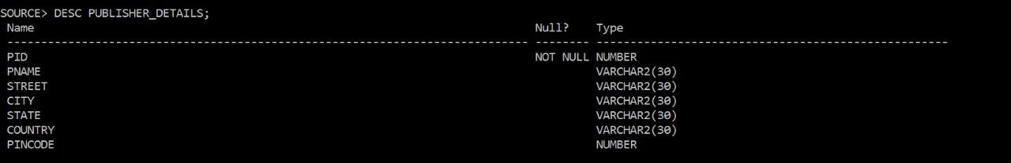

DATA:

Insert into Author_details select rownum,dbms_random.string(‘U’,10),dbms_random.string(

‘U’,8),dbms_random.string(‘U’,5),dbms_random.string(‘U’,5),dbms_random.string(‘U’,6),

floor(dbms_random.value(500000,600000)) from dual connect by level<=50;

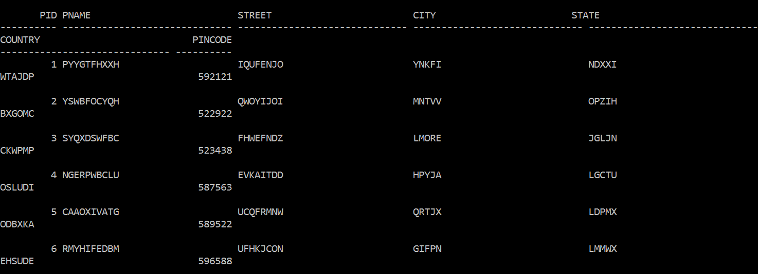

AUTHOR_DETAILS

Create Table Author_details(Aid number Primary Key, Aname Varchar(30),Dno number,

Street Varchar(30),City varchar(30),State varchar(30),Country Varchar(30),Pincode

Number);

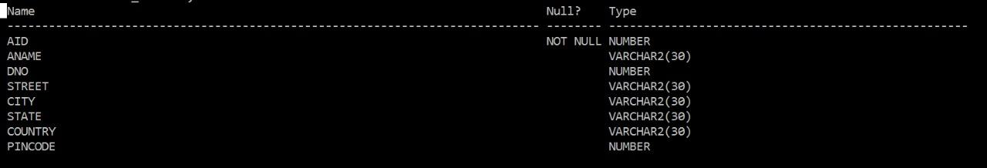

DATA:

Insert into Author_details select rownum,dbms_random.string(‘U’,10),floor(dbms_random.

value(1000,2000),dbms_random.string(‘U’,8),dbms_random.string(‘U’,5),dbms_random.

string(‘U’,5),dbms_random.string(‘U’,6),floor(dbms_random.value(500000,600000)) from

From dual connect by level<=50;

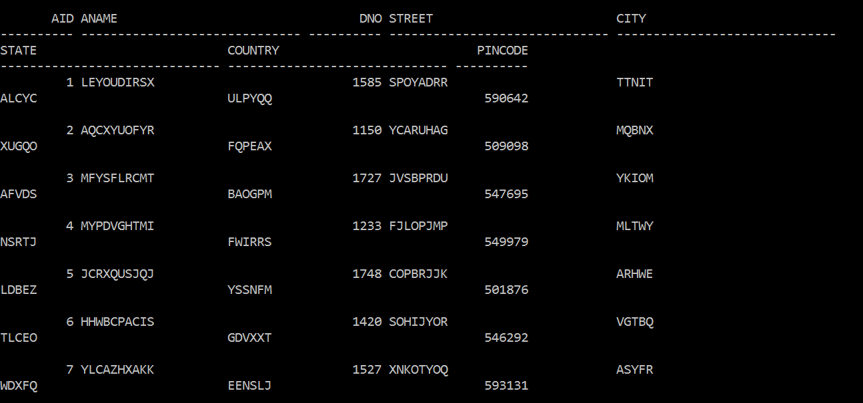

BOOK_DETAILS

Create Table Book_details(Bid Number,Title Varchar(30),AuthorId number,PublisherId

Number,Publication_date date,No_of_pages Number,Mrp Number,Constraint Pk1 Primary

Key(Bid,Mrp),Constraint Fk1 Foreign key(AuthorId) references Author_details(Aid),

Constraint Fk2 Foreign Key(PublisherId) references Publisher_details(Pid));

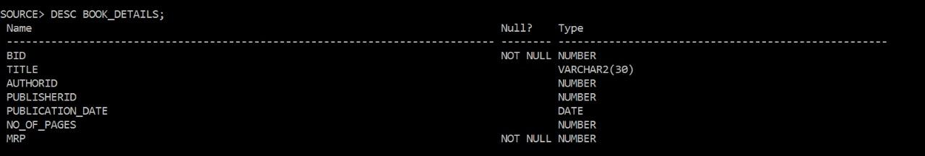

DATA:

Insert into book_details select rownum,dbms_random.string(‘U’,10),floor(dbms_random.value(1,50)),floor(dbms_

random.value(1,50)),trunc(sysdate)-floor(dbms_value(10,900)),floor(dbms_random.value

(100,900)),floor(dbms_random.value(100,700)) from dual connect by level<=50;

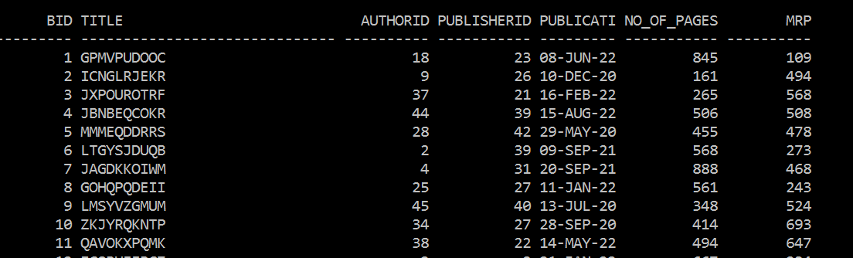

CUSTOMER_DETAILS

Create Table Customer_details(Cid number Primary Key,Cname Varchar(30),Age Number,

Gender Varchar(10),Dno Number,Street Varchar(30),City varchar(30),State varchar(30),

Country Varchar(30),Pincode Number);

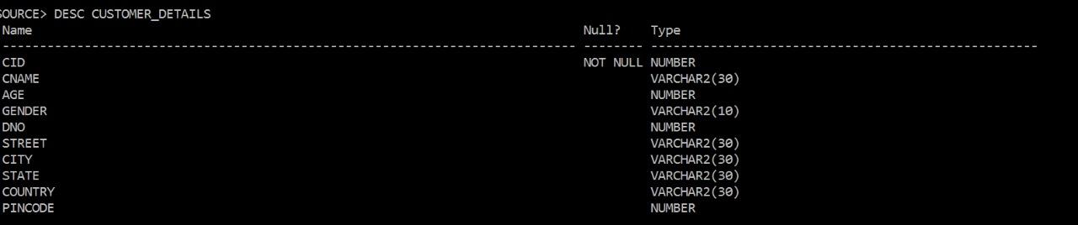

DATA:

Insert into customer_details(cid,cname,age,dno,street,city,state,country,pincode)select rownum,dbms_random.string(‘U’,5),floor(dbms_random.value(10,70)),floor

(dbms_random.value(1000,2000)),dbms_random.string(‘u’,7),dbms_random.string(‘u’,5),

dbms_random.string(‘u’,5),dbms_random.string(‘u’,5),floor(dbms_random.value

(500000,600000)) from dual connect by level<=50;

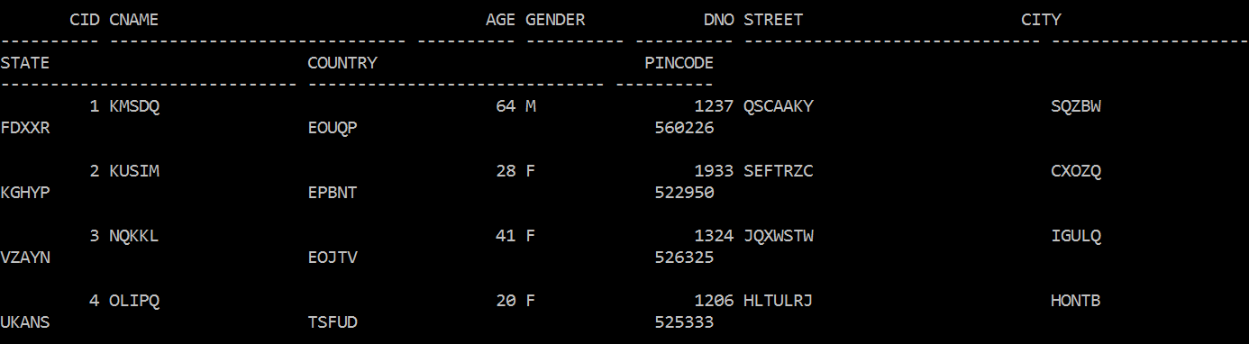

SALES_DETAILS

Create Table Sales_details(Cid Number,Bid Number,Pid Number,Quantity Number,Price

Number,Total_Price Number,Discount Number,Final_Price Number,Constraint Fk1_Sales

Foreign Key(Cid) references Customer_Details(Cid),Constraint Fk2(Bid,Price) references

Book_details(Bid,Mrp),Constraint Fk3_Sales Foreign Key(Pid) references Publisher_

details(Pid));

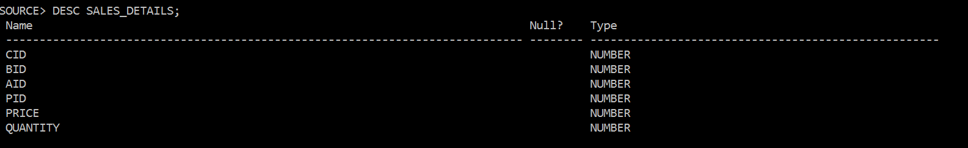

DATA:

Insert into Sales_details values(50,50,42,8,474,1);

Insert into Sales_details values(49,49,3,3,660,2);

Insert into Sales_details values(48.48,10,12,485,1);

